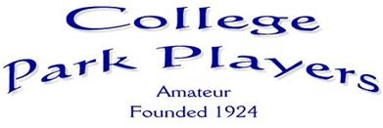
PRESENTS
MTHER
OOSE
A PANTO FOR ALL THE FAMILY
BURNT ASH METHODIST CHURCH HALL, LEE SE12 0QD
THURSDAY 5th DECEMBER 2019 at 7.45pm,
FRIDAY 6th DECEMBER 2019 at 7.45pm, and
SATURDAY 7th DECEMBER 2019 at 1pm and 6pm
BOX OFFICE - rynlnd@aol.com TICKETS £8.00 (£7.00 Concessions)
WWW.COLLEGEPARKPLAYERS.COM COLLEGE PARK PLAYERS
COLLEGEPARKPLAYERS CPPDRAMA
` LOOP SYSTEM IN OPERATION

